Menu (Item) on/off
Path : billing.petpooja.com > Menu > Menu (Item) on/off
outletwise_link : https://menu.petpooja.com/menus/item_on_off//
Steps to reach Online Menu (Item) on/off:
Step 1 : Billing.petpooja.com in Steps to reach Menu (Item) on/off : Open your browser and go to billing.petpooja.com.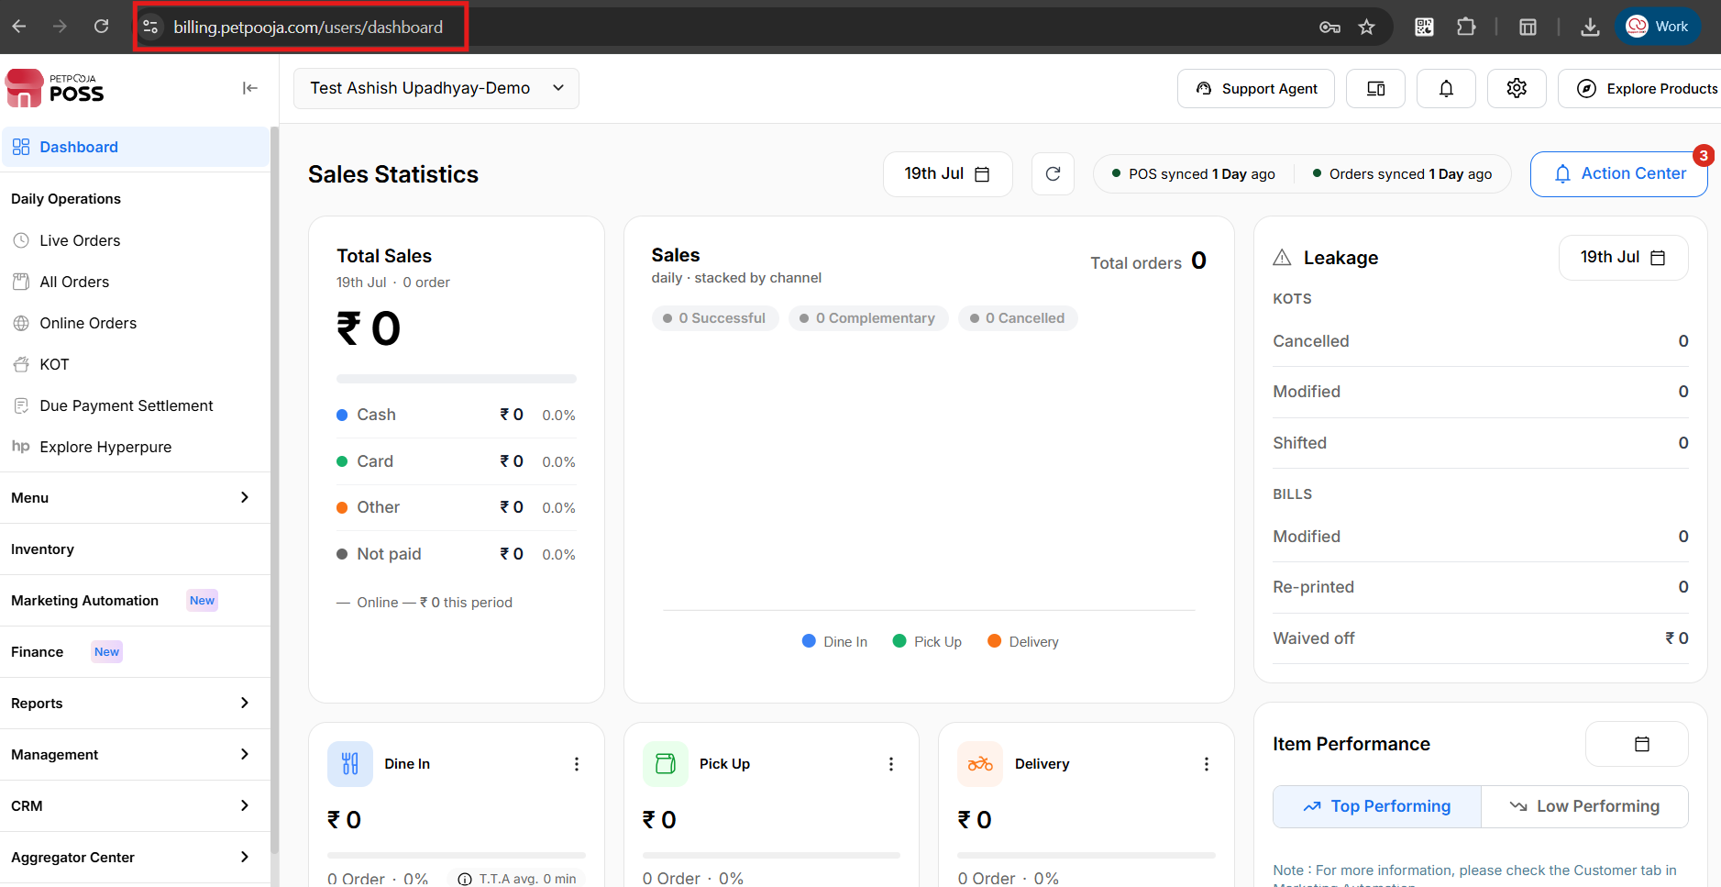
{Image Name: PetPooja Dashboard,
Description: The highlighted URL indicates that this is the billing.petpooja.com.Here is an image of step 1 Billing.petpooja.com in Steps to reach Online Menu (Item) on/off.}
Step 2 : Menu in Steps to reach Online Menu (Item) on/off : Click on the Menu section from the dashboard.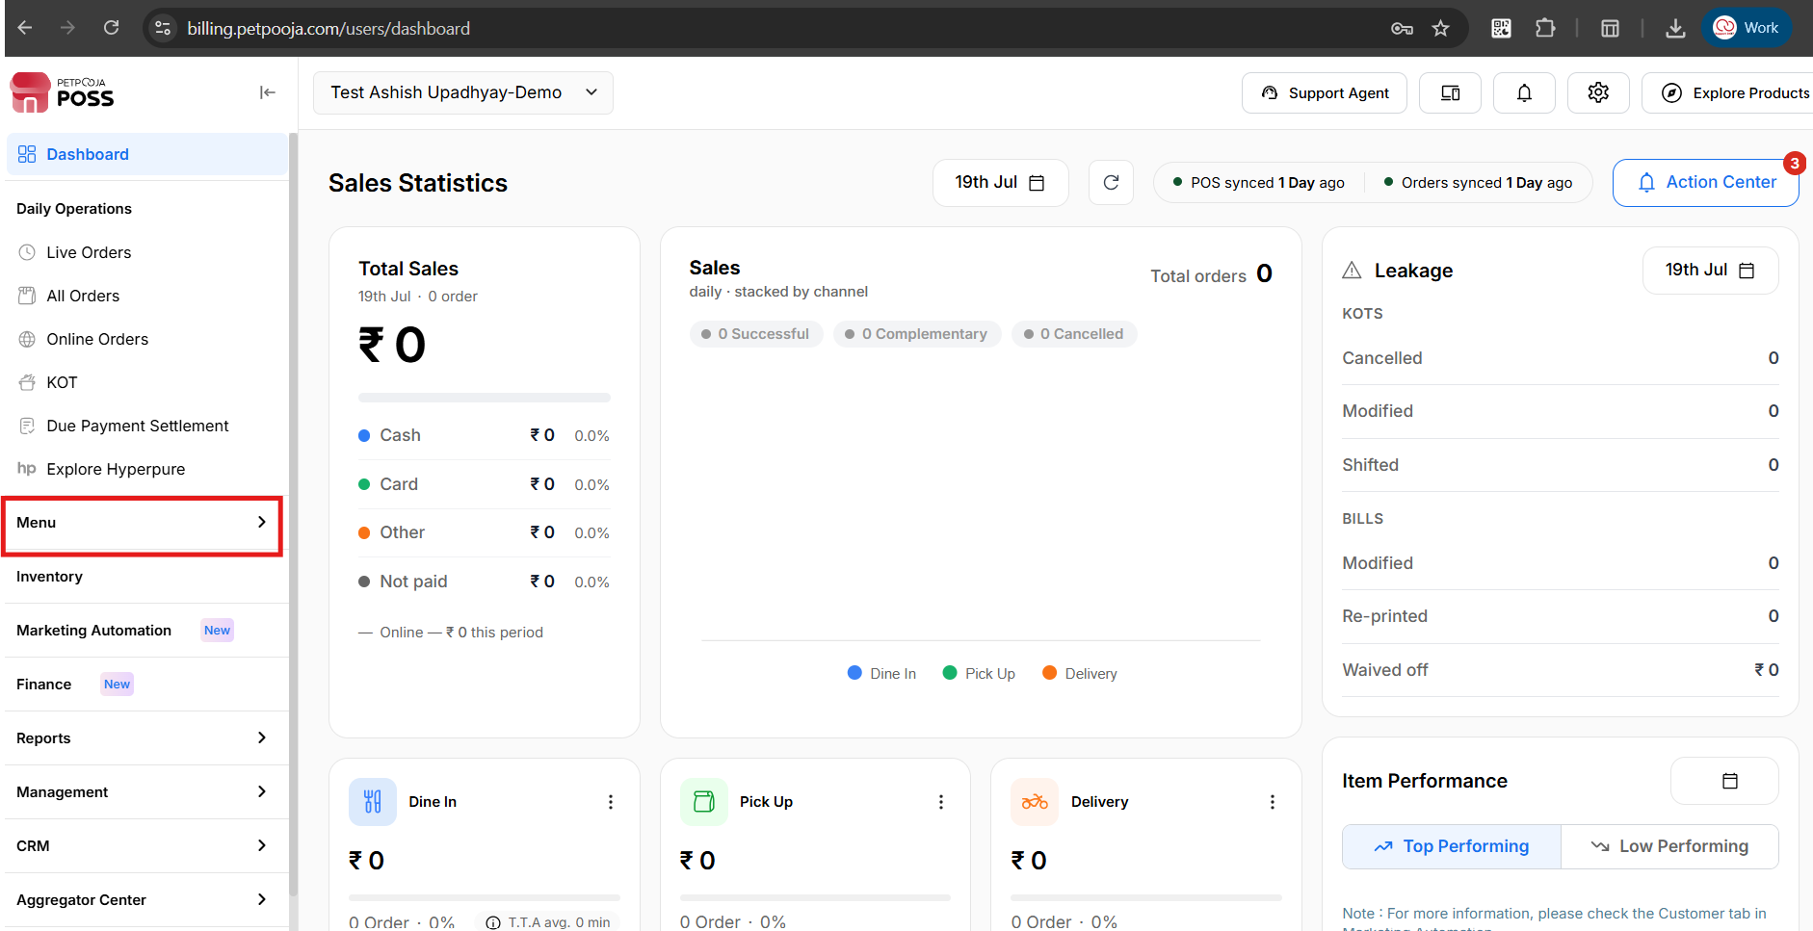
{Image Name: Dashboard Menu Navigation,
Description: The highlighted “Menu” option in the left navigation panel of billing.petpooja.com guides users toward menu-related settings and configurations. Here is an image of step 2 Menu in Steps to reach Online Menu (Item) on/off.}
Step 3 : Online Menu (Item) on/off in Steps to reach Online Menu (Item) on/off : Inside the Menu section, click on Online Menu (Item) on/off.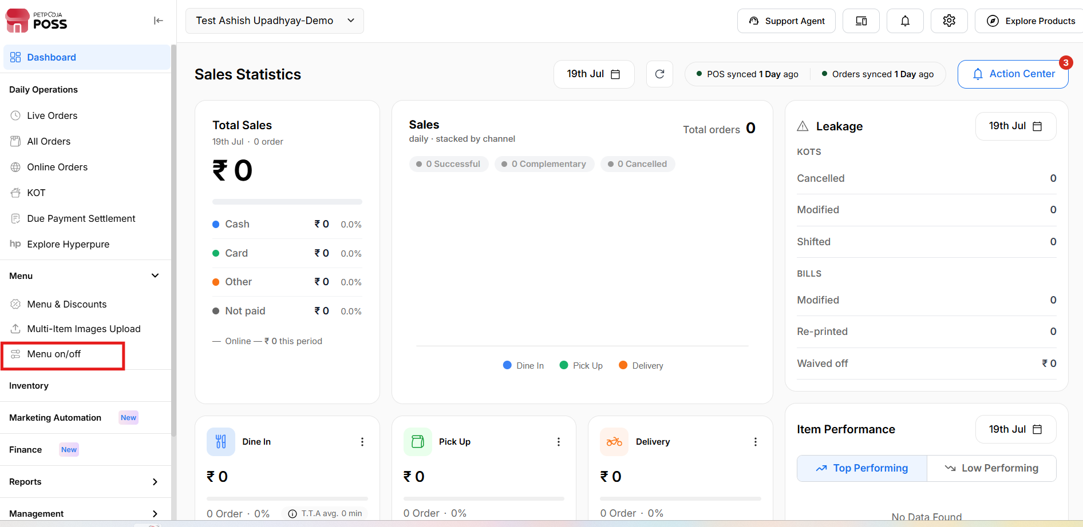
{Image Name:Online Menu (Item) on/off,
Description: The highlighted “Online Menu (Item) on/off” option under the “Menu” section allows users to control the availability of their online menu. Here is an image of step 3 Online Menu (Item) on/off in Steps to reach Online Menu (Item) on/off.}

Key Features of Online Menu (Item) on/off :
outletwise_link : https://menu.petpooja.com/menus/item_on_off//
1. Tab Navigation (Online Menu (Item) on/off) :
outletwise_link : https://menu.petpooja.com/menus/item_on_off//
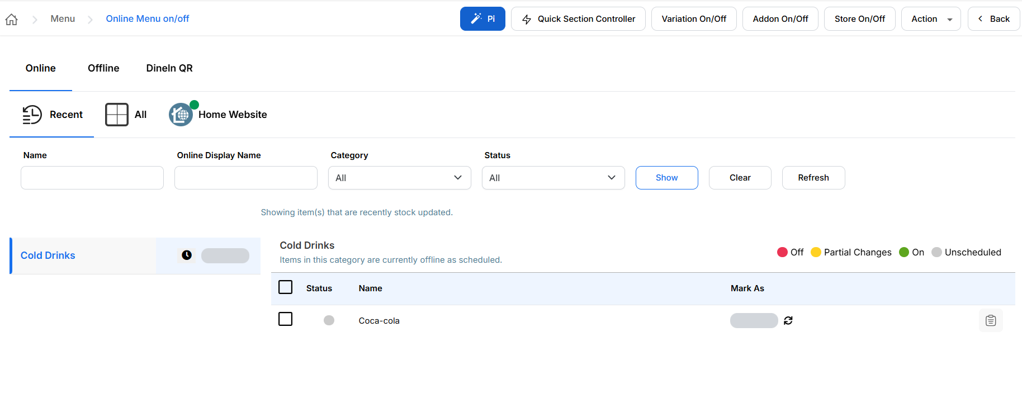
{Image Name: Online Menu Filtering Options,
Description: Here is an image of Showing the Online Menu interface with three main filtering options.}
At the top, there are three tabs:
- Recent (Tab Navigation) : View recently accessed items.
- All (Tab Navigation) : Shows all available items.
- Home Website (Tab Navigation) : Likely a filtered view for menu items shown on the home website.

2. Filters Section (Online Menu (Item) on/off) :
outletwise_link : https://menu.petpooja.com/menus/item_on_off//
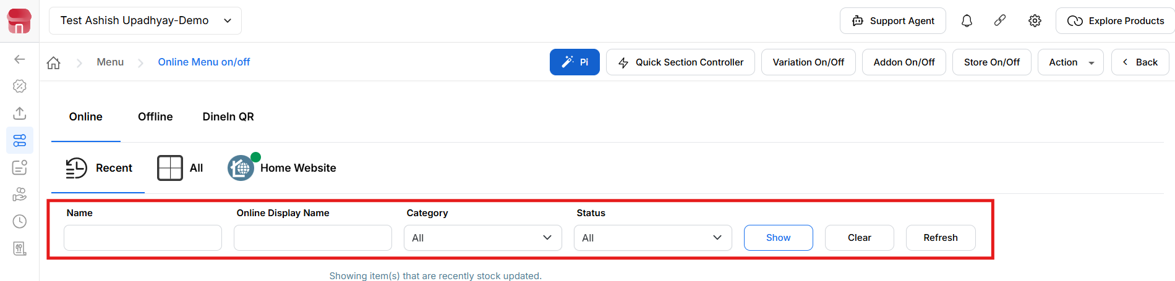
{Image Name: Online Menu (Item) on/off Filter Section,
Description: Here is an image highlighting the filtering section of the "Online Menu (Item) on/off" screen.}
You can filter the menu items using these fields:
- Name(Filters Section) : Enter the internal name of the item.
- Online Display Name(Filters Section) : Enter the name as it appears online.
- Category(Filters Section) : Dropdown to filter by food categories (e.g., Beverages, Main Course).
- Status (Filters Section) : Dropdown to filter by online/offline status.
- Show (Filters Section) : Displays the items based on filter criteria.
- Clear (Filters Section) : Resets all filter fields.
- Refresh (Filters Section) : Reloads the page or data list.
Item ON / OFF Process :
In the Online section, multiple platforms or areas will be visible at the top (for example: Zomato, Swiggy, or specific brand/area).

Click on the platform or area where you want to manage item availability.

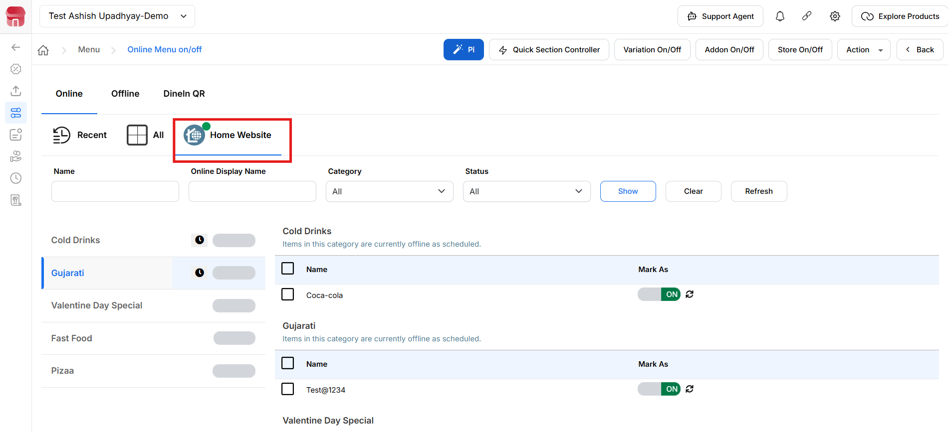

{Image Name: Online Menu (Item) ON/OFF – Platform Selection,
Description: This image highlights the Online Menu ON/OFF section, where the user can select the required platform/area to manage item availability.}
After selecting the platform, categories will appear on the left side (such as Cake, Accompaniments, Salads, etc.).
Click on any category to view the list of items under that category.

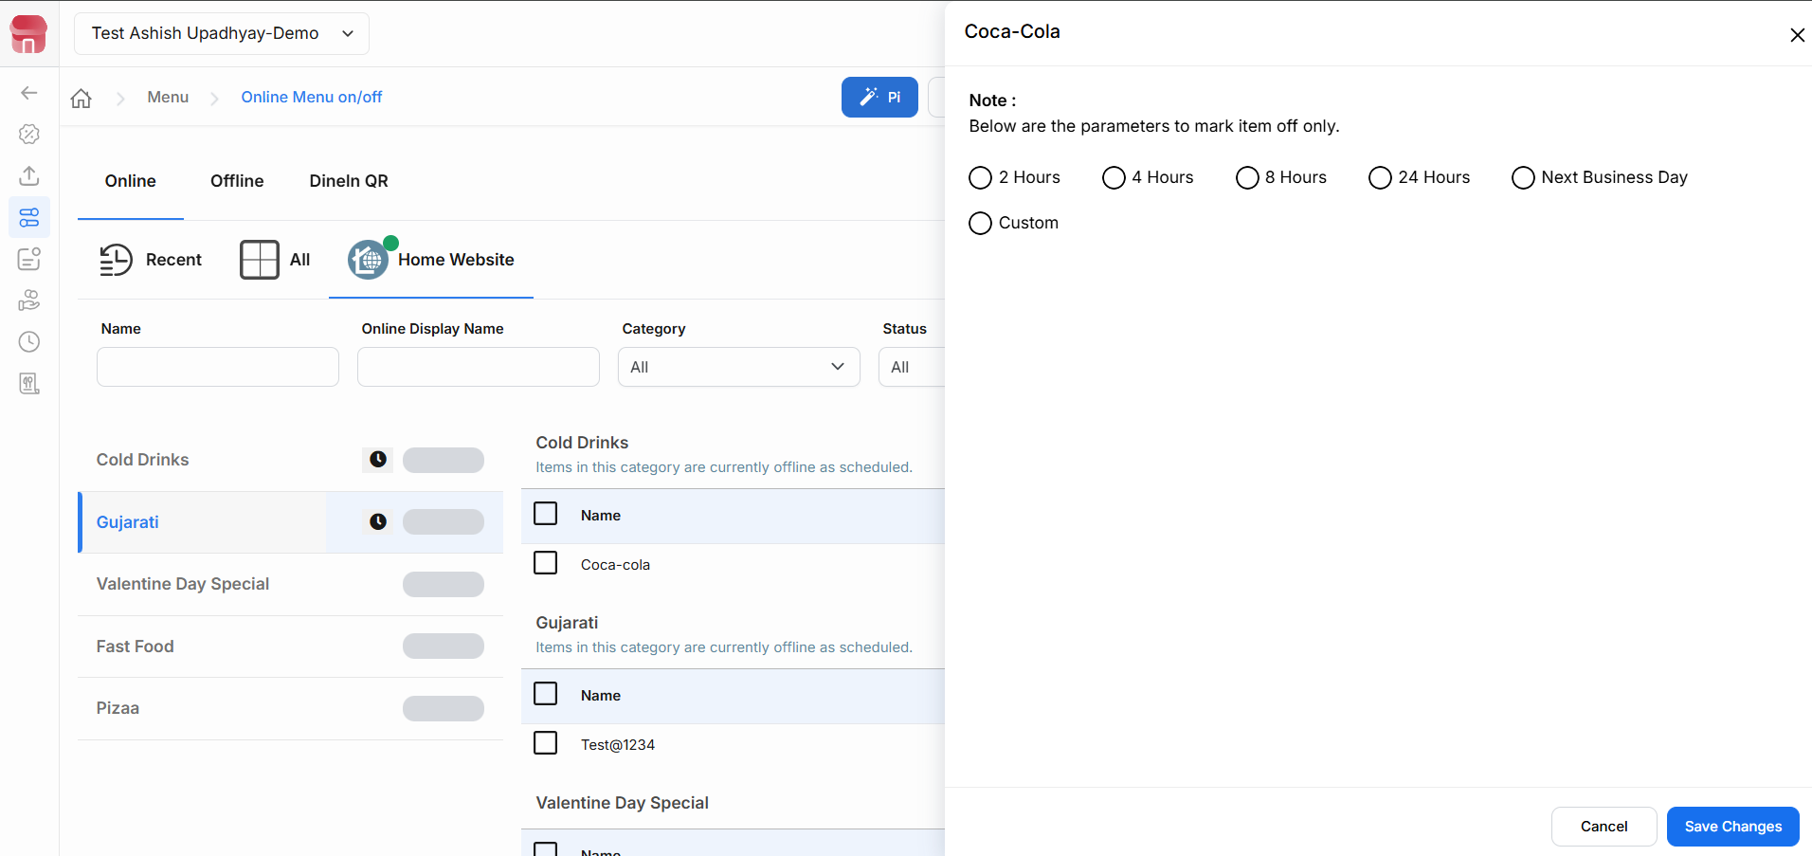

{Image Name: Online Menu (Item) ON/OFF – Item OFF Duration Options
Description: This image shows the pop-up window that appears when an item is turned OFF, allowing the user to select the OFF duration based on business requirements.}
When an item is marked OFF, a pop-up window opens displaying multiple duration options, including 2 Hours, 4 Hours, 8 Hours, 24 Hours, Indefinite, Next Business Day, and Custom. The appropriate OFF duration can be selected based on business requirements, and clicking on Save Changes will apply the update.
To make the item available again, the item toggle can be switched back to ON. Once enabled, the change will be reflected immediately on the selected platform.
Important Note : This process is applicable for managing item availability across multiple online platforms, including Zomato, Swiggy, Magicpin, DotPe, Ownly, Uengage, Muncho, Keeta and AirMenus. Item ON/OFF actions must be performed by selecting the respective platform or area within the Online Menu ON/OFF section.

Key Features of Offline Menu (Item) on/off :
outletwise_link : https://menu.petpooja.com/menus/item_on_off/6

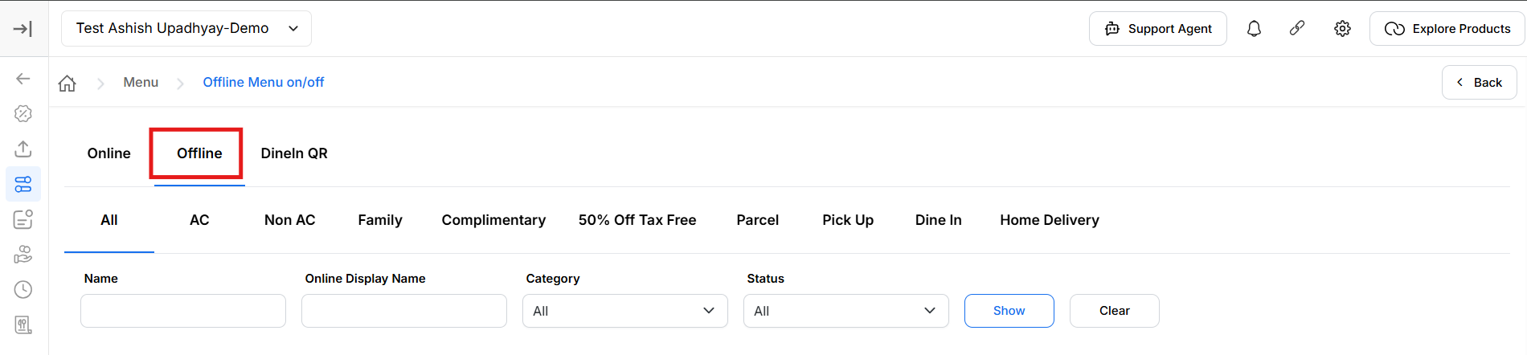

{Image Name: Offline Menu (Item) on/off Tab,

Description: The red box highlights the Offline tab, which allows users to manage and control menu items that should be available when the outlet is operating in offline mode,}

This screen allows you to manage menu items that are available in Offline mode.

Offline: Shows items available only for offline use (for example, dine-in or POS orders).

Selecting Offline lets you control which items should appear when the system is used offline.

Areas Section Tabs (All, AC, Garden, Home Delivery, Parcel, etc.):These tabs help filter menu items based on different order types or service areas.
- Filters:
  - Name: Search items by item name.
  - Online Display Name: Search by the display name shown to customers.
  - Category: Filter items by category.
  - Show: Applies the selected filters and displays matching items.
  - Clear: Resets all filters and shows the full list again.

Dine In QR
Overview: The Dine In QR tab allows users to manage and control the menu items that are available for customers when ordering through the Dine In QR service. Users can enable or disable specific menu items to ensure that only the required items are displayed in the Dine In QR menu.

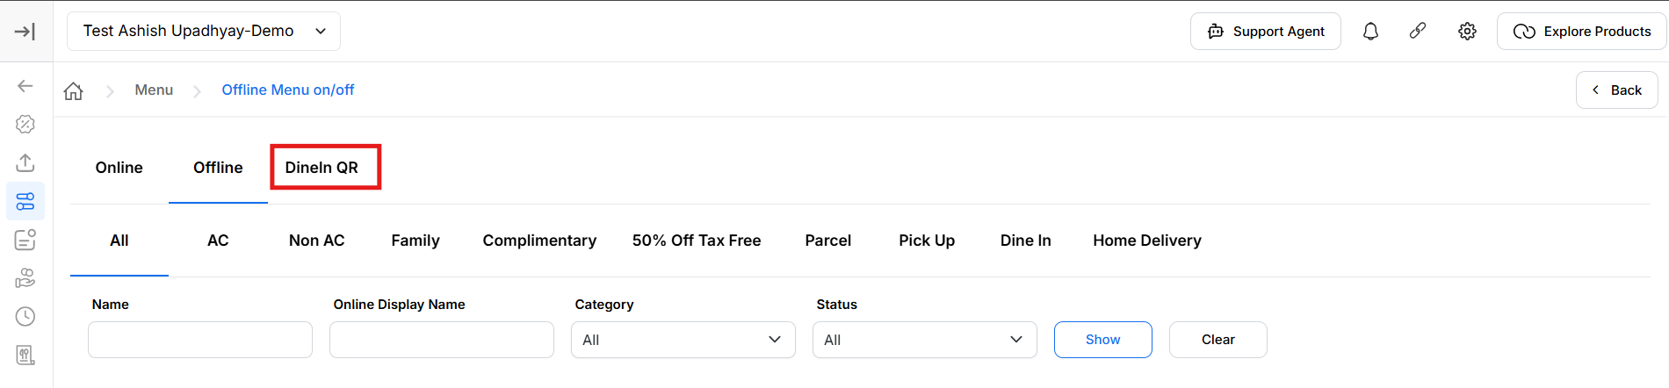

{Image Name: Dine QR Menu (Item) on/off Tab,

Description: The highlighted Dine In QR tab allows users to manage the availability of menu items specifically for the Dine In QR ordering platform. Selecting this tab displays all menu items configured for Dine In QR, where users can enable or disable item availability as required. The screen also provides filters such as Area, Category, Status, and Item Name to quickly search and manage menu items.}

This screen allows you to manage menu items that are available for Dine In QR.

3. Top Action Buttons (Online Menu (Item) on/off) :
These buttons allow you to toggle the online status of menu components:

Variation On/Off (Online Menu (Item) on/off) :
outletwise_link : https://menu.petpooja.com/menus/item_on_off/5/
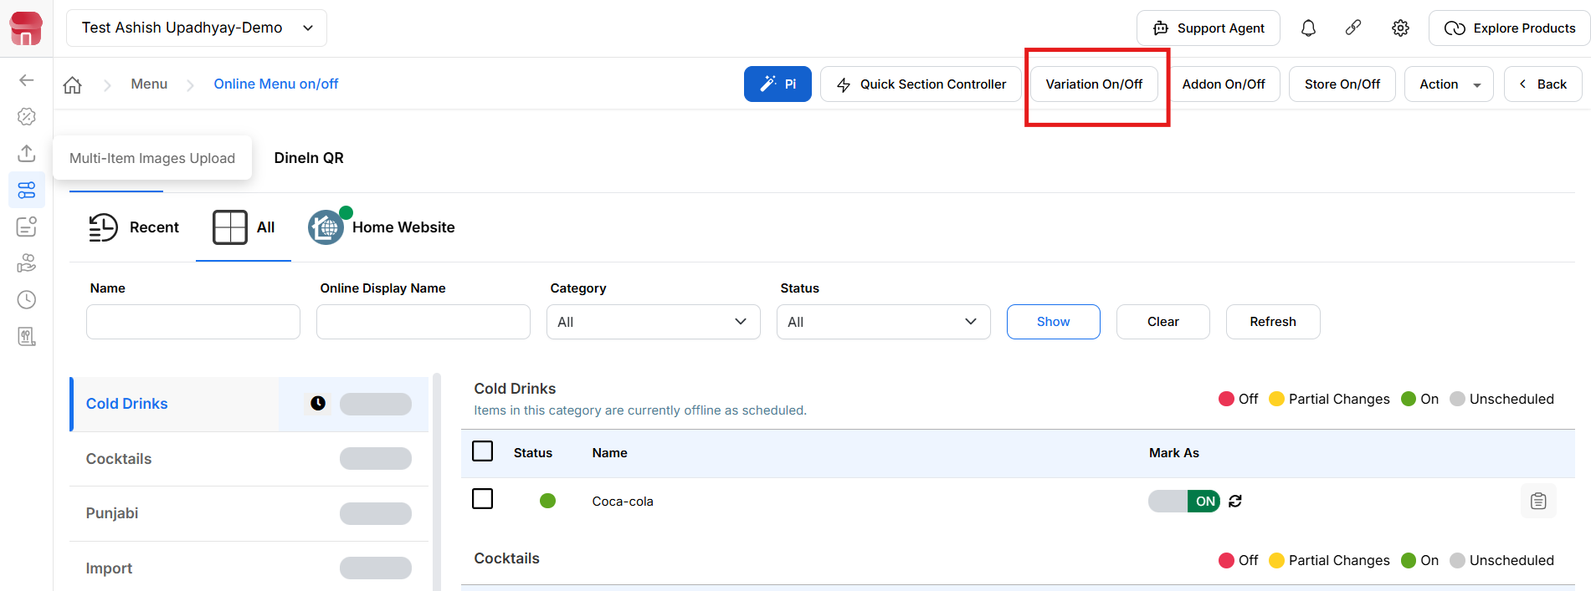
{Image Name: Variation On/Off,
Description: Here is an image of highlights the "Variation On/Off" option within the Online Menu interface}

Key features of Variation On/Off (Variation On/Off) :
outletwise_link : https://menu.petpooja.com/menus/item_on_off/5/
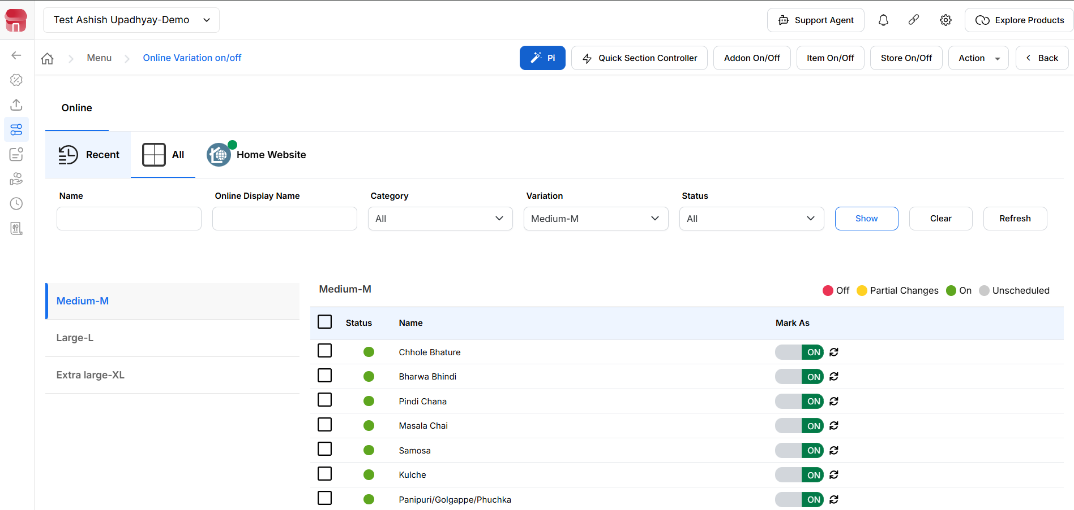
{Image Name: Online Menu Item,
Description: Here is an image highlighting the filtering section of the "Variation On/Off" Screen.}
1. Filter Section (Variation On/Off) :
outletwise_link : https://menu.petpooja.com/menus/item_on_off/5/
You can narrow down your search by using these filters:
- Name (Filter Section) : Type in the internal name of the item.
- Online Display Name (Filter Section) : Type the name as seen by customers online.
- Category (Filter Section) : Select a category (e.g., Beverages, Starters, etc.).
- Variation (Filter Section) : Choose the item size (Small / Medium / Large).
- Status (Filter Section) : Filter by status (All, On, Off, Partial, etc.).
- (Filter Section) Click "Show" to apply filters.
- (Filter Section) Click "Clear" to reset the fields.
- (Filter Section) Click "Refresh" to reload the data

Step 1: Choose a Category (Variation On/Off) :
outletwise_link : https://menu.petpooja.com/menus/item_on_off/5/
- On the left-hand side, a list of item categories is displayed (e.g., PIZZA).
- Select a category to load its items on the right panel.

Step 2: View Category Items (Variation On/Off) :
outletwise_link : https://menu.petpooja.com/menus/item_on_off/5/
- Once a category is selected, the right panel shows all items under that category.
- You’ll see:
  - Item Name (e.g., Testing Item)
  - Mark As toggle button (ON/OFF)

Step 3: Toggle Item Availability (Variation On/Off):
outletwise_link : https://menu.petpooja.com/menus/item_on_off/5/
- Use the switch under Mark As to enable (ON) or disable (OFF) the item.
  - ON → The item is available on the menu.
  - OFF → The item is hidden from the menu.

Step 4: Refresh Item Status (Variation On/Off):
outletwise_link : https://menu.petpooja.com/menus/item_on_off/5/
- Next to the toggle switch is a refresh icon.
- Click it to sync the current status of the item with the latest system state.
  - This ensures any external or manual changes are reflected properly.

Step 5: Select Items for Bulk Actions (Variation On/Off) :
outletwise_link : https://menu.petpooja.com/menus/item_on_off/5/
- Use the checkboxes beside each item to select one or multiple items.
- This selection may be used for future bulk actions like update or delete (if supported in the system).

Addon On/Off (Online Menu (Item) on/off) :
outletwise_link : https://menu.petpooja.com/menus/item_on_off/4/
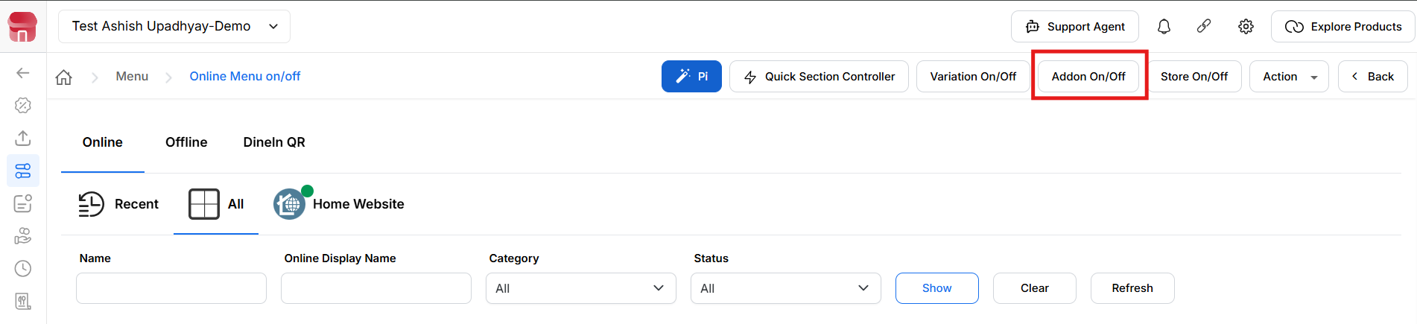
{Image Name: Addon On/Off Toggle,
Description: This image shows the Online Menu interface with the 'Addon On/Off' highlighted, used to enable or disable add-ons.}

Key features of Addon On/Off (Addon On/Off):
outletwise_link : https://menu.petpooja.com/menus/item_on_off/4/
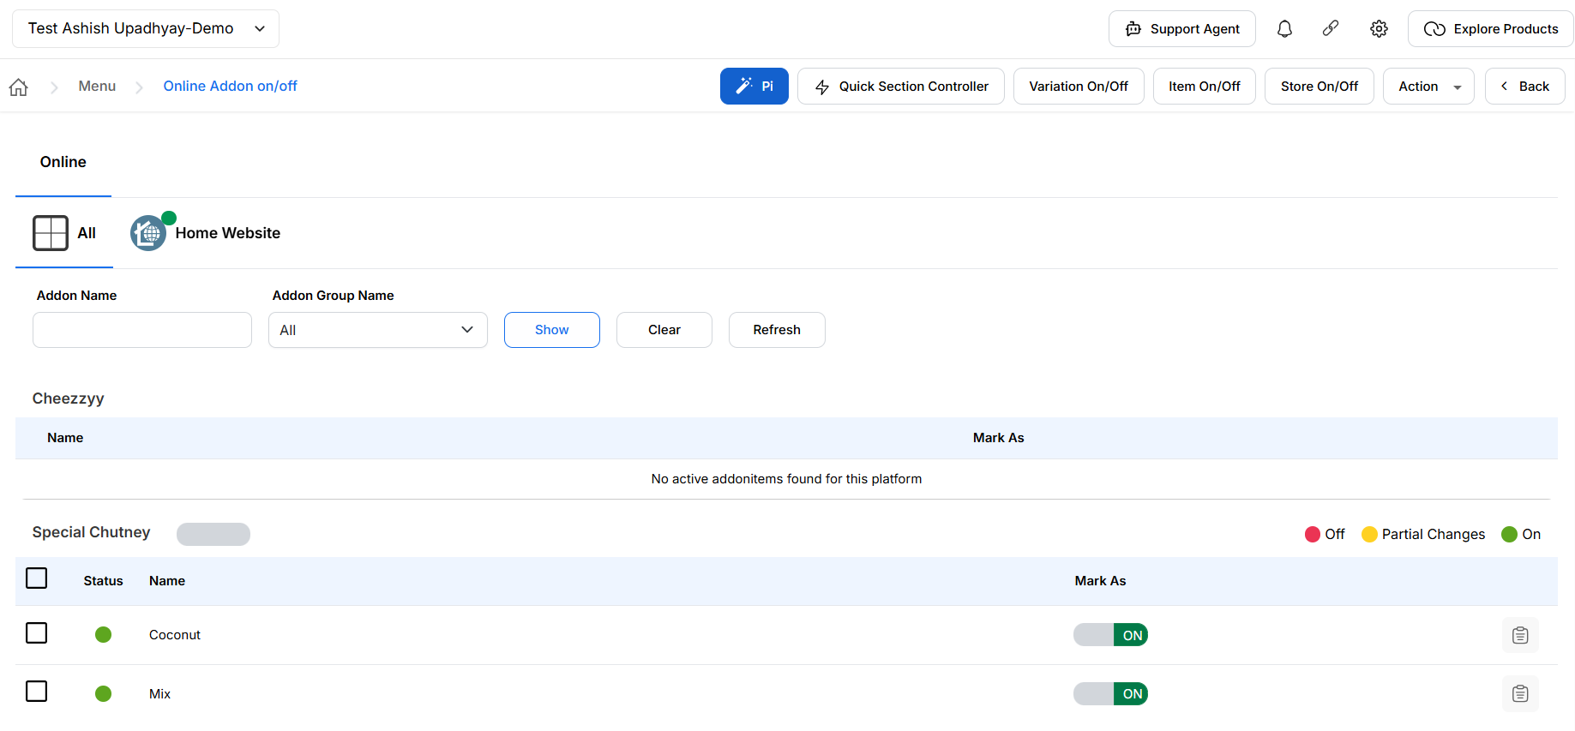
{Image Name: Online Addon On/Off Screen,
Description: This image displays the Online Addon On/Off interface with options to enable or disable specific toppings like Extra Cheese, Sausage, and Pineapple Chunks.}

Step 1: Filter Addons (Addon On/Off) :
outletwise_link : https://menu.petpooja.com/menus/item_on_off/4/
- Use the filters at the top to narrow down the results:
  - Addon Name – Search by a specific addon/topping name.
  - Addon Group Name – Choose a group from the dropdown.
  - Click Show to apply the filter.
  - Click Clear to reset the fields.
  - Click Refresh to reload the addon list.

Step 2: View Addon List (Addon On/Off) :
outletwise_link : https://menu.petpooja.com/menus/item_on_off/4/
- Below the filter section, all available toppings (addons) are listed under the selected group.
- Each row displays:
  - Status Indicator:
    - 🟢 Green = Enabled
    - 🟡 Yellow = Partial Changes
    - 🔴 Red = Disabled
  - Name of the addon (e.g., Extra Cheese, Sausage)
  - Mark As toggle switch to control visibility
  - Delete Icon to remove the addon (if supported)

Step 3: Enable/Disable Toppings (Addon On/Off):
outletwise_link : https://menu.petpooja.com/menus/item_on_off/4/
- Use the Mark As ON/OFF toggle switch to manage each topping’s availability:
  - ON → Addon is visible and selectable.
  - OFF → Addon is hidden or inactive.

Step 4: Delete Addon (Optional) (Addon On/Off):
outletwise_link : https://menu.petpooja.com/menus/item_on_off/4/
- Click the trash icon next to an addon to remove it from the list.
  - A confirmation prompt may appear based on your system's settings.

Store On/Off (Online Menu (Item) on/off) :
outletwise_link : https://menu.petpooja.com/menus/item_on_off//
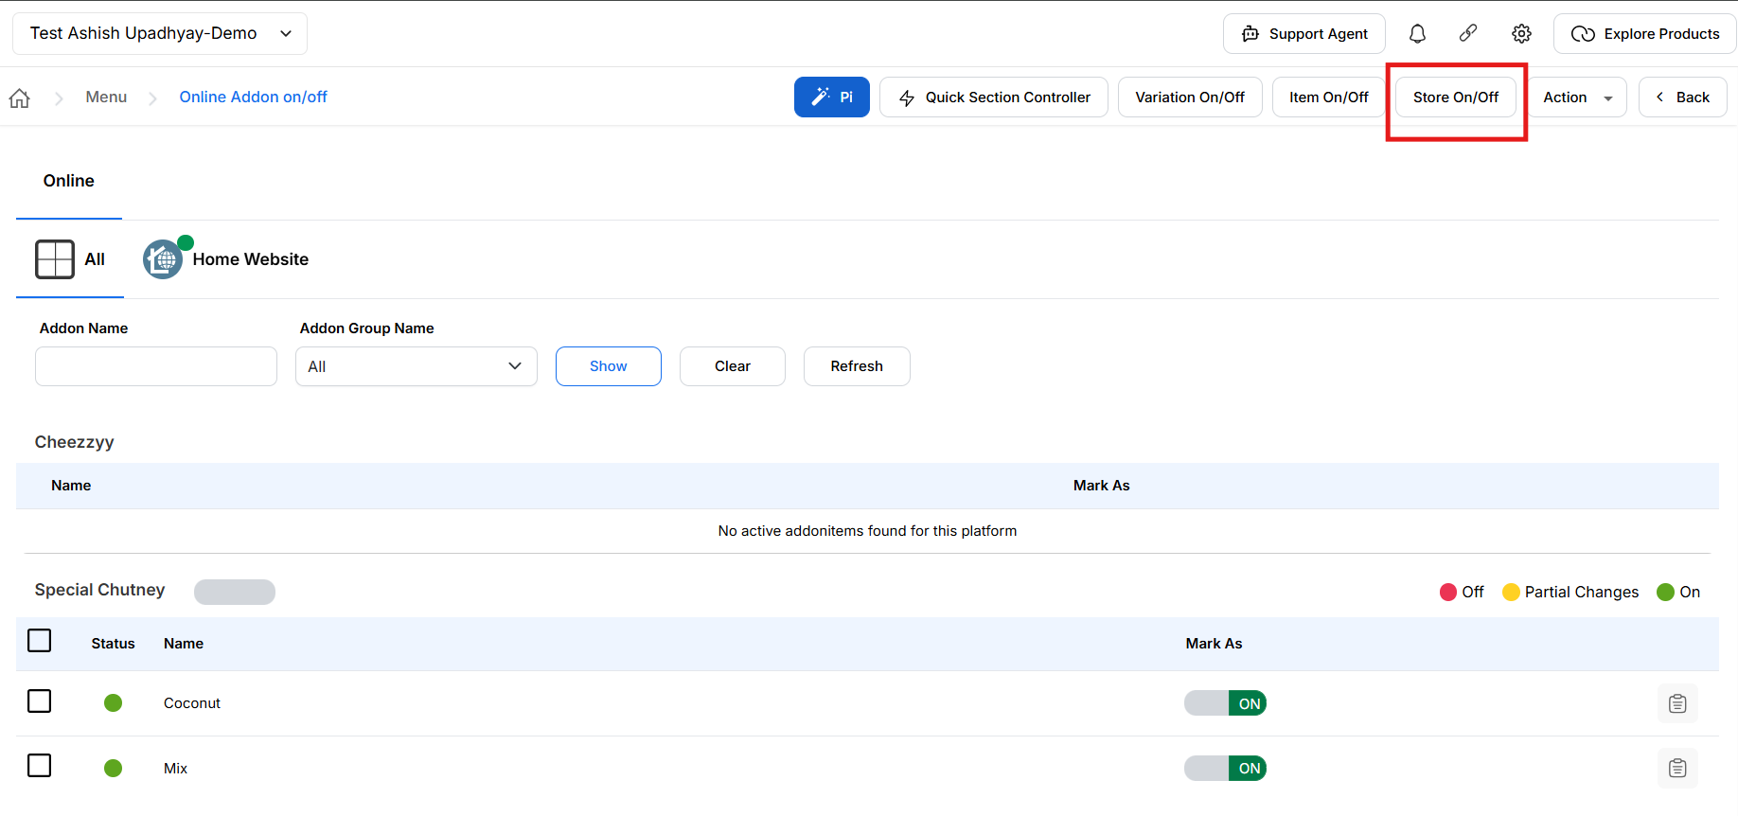
{Image Name: Online Store On/Off Screen,
Description: This image shows the Online Store On/Off interface, allowing the user to manage store visibility settings through filtering options like Name, Category, and Status.}

Key features of Store On/Off (Store On/Off) :
outletwise_link : https://menu.petpooja.com/menus/item_on_off//
Description : To turn a store on or off, first click on Store On/Off. You will see two ways to manage this. The first is Update All Store Status, which lets you manage multiple outlets at the same time. In this option, you will also see two choices: Open for Delivery and Close for Delivery—if you want to keep the outlets active, select Open for Delivery, and if you want to stop orders, select Close for Delivery. After that, choose the turn-off duration, select a reason (you can use “Other” to type your own reason), select the outlets such as Zomato or Swiggy, and click Save Changes. The selected outlets will be updated. The second way is to manage stores individually—go to the outlet you want, click the On/Off button, choose the duration and reason, and save the changes.

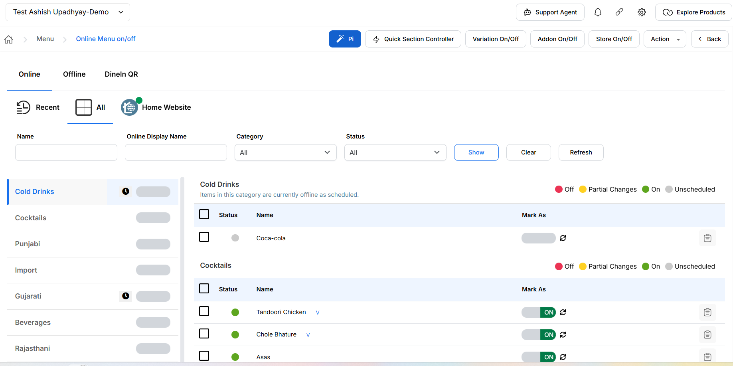
{Image Name: Online Menu On Off,
Description: The image shows the Rappooja POS interface for managing online menu availability with store on/off controls and item status management.}

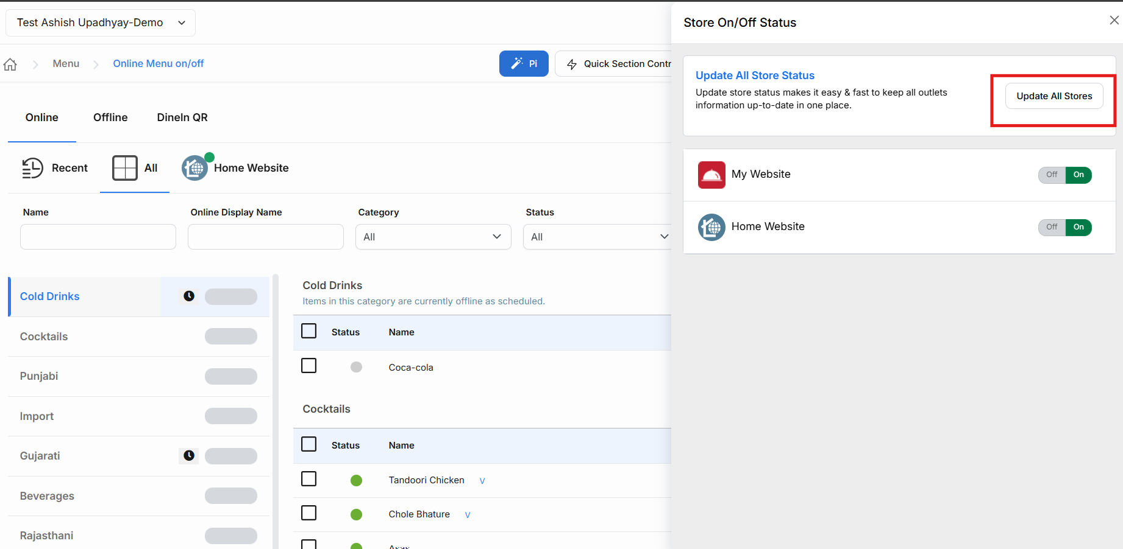
{Image Name: Store Status Update,
Description: The image shows the Rappooja POS interface where store on/off status is managed across multiple online delivery platforms.}
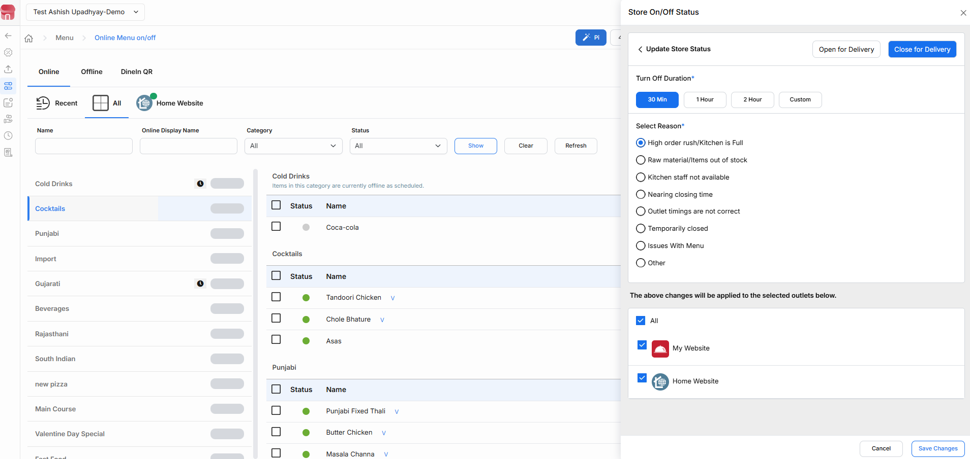
{Image Name: Online Menu Control,
Description: The image shows the Petpooja POS interface for managing online menu availability and store on/off status across delivery platforms.}

Note (Store On/Off) :
outletwise_link : https://menu.petpooja.com/menus/item_on_off//
- This feature is especially useful when managing multiple branches or switching availability across platforms.
- Always confirm that your store status is set to ON before launching new menus or updates.
- Individual Store On/Off
- Open the specific outlet you want to manage, click the On/Off button, select the duration and reason, and save the changes. The store for that outlet will be turned off on Swiggy, Zomato, uEngage, Magicpin, Muncho, Ownly, Keeta and DotPe.

Sort Store (Online Menu (Item) on/off) :
outletwise_link : https://menu.petpooja.com/menus/item_on_off//

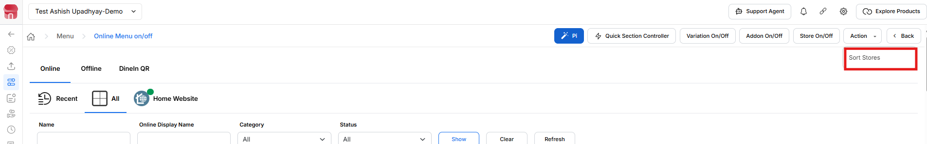
{Image Name: Sort Stores,
Description: This image displays the "Sort Stores" option in the Online Menu interface, allowing users to organize the store order.}

Key features of Sort Stores (Sort Store) :
outletwise_link : https://menu.petpooja.com/menus/item_on_off//
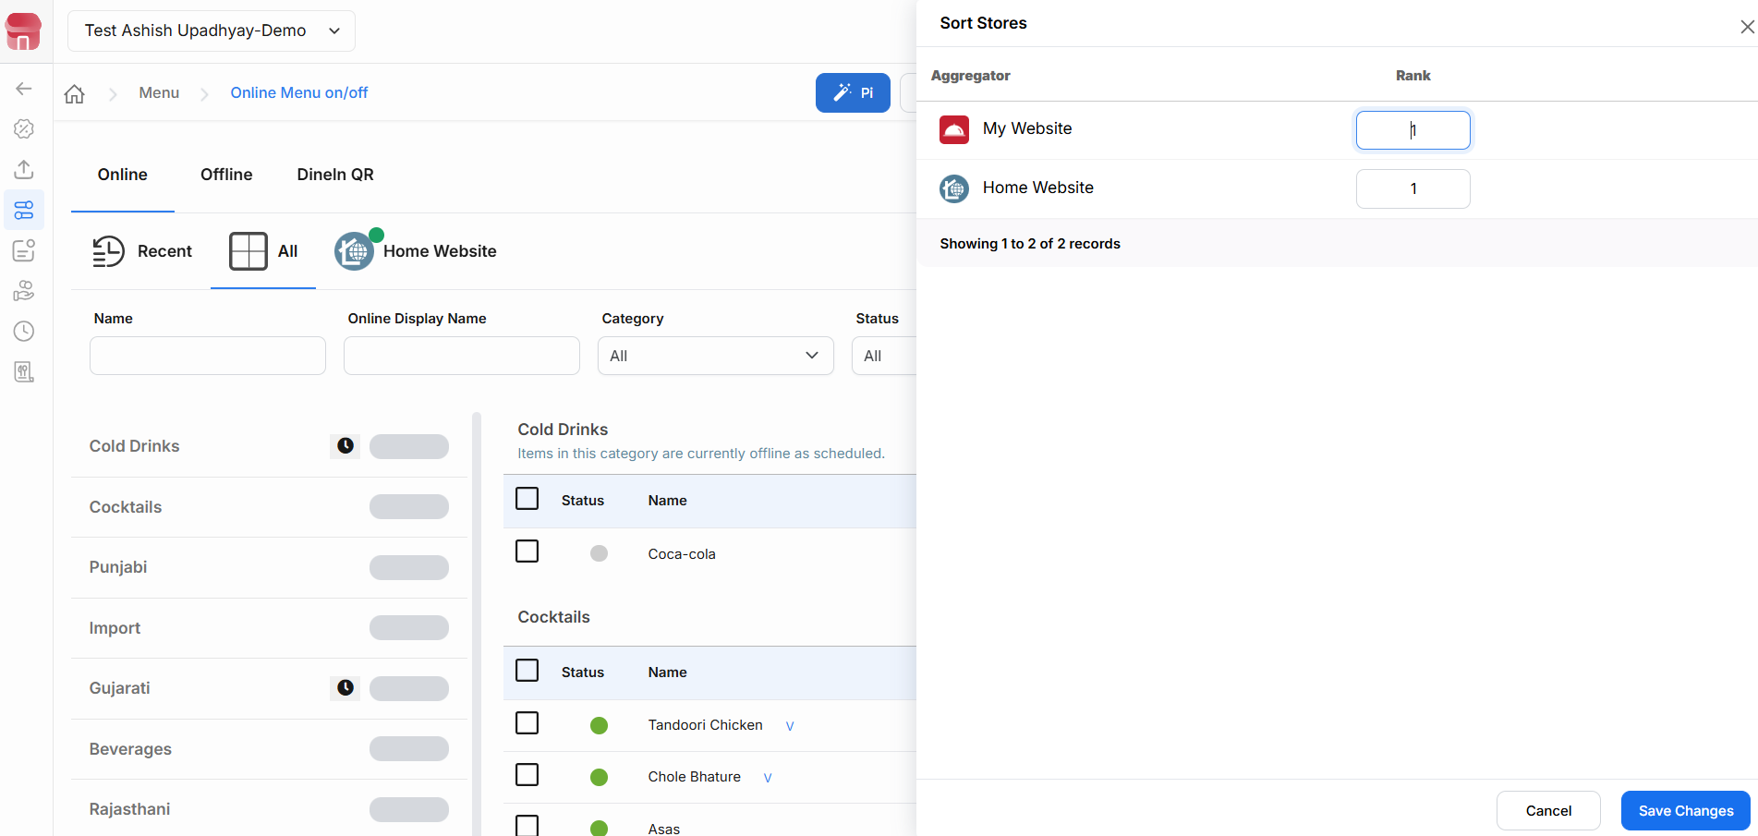
{Image Name: Sort Stores - Save Changes,
Description: Here is an image showing the "Sort Stores" popup.}
Step 1: Open Sort Stores (Sort Store) :
outletwise_link : https://menu.petpooja.com/menus/item_on_off//
- Go to the section labeled Sort Stores from your admin/settings menu.
Step 2: View Store List (Sort Store) :
outletwise_link : https://menu.petpooja.com/menus/item_on_off//
- Under the Aggregator column, you'll see the available store(s).
  - Example: Home Website
Step 3: Set Rank Order (Sort Store) :
outletwise_link : https://menu.petpooja.com/menus/item_on_off//
- In the Rank column, enter a numeric value to define the priority.
  - Lower numbers show higher priority (e.g., Rank 1 will appear first).
  - If only one store exists, it’ll default as the top item.

Step 4: Save Your Changes (Sort Store) :
outletwise_link : https://menu.petpooja.com/menus/item_on_off//
- After assigning the rank:
  - Click Save Changes (bottom-right) to update the sort order.
  - Or use Cancel if no changes are needed.

5. Back Button (Online Menu (Item) on/off) :
outletwise_link : https://menu.petpooja.com/menus/item_on_off//
- Click Back to return to the previous menu or screen.

